**CIE 2 : Arduino with LCD and Temperature Sensor**

**Aim :** To interface an LCD display and a temperature sensor (such as LM35 or DHT11) with an Arduino to display real-time temperature readings.

**Overview :**

This project demonstrates how an Arduino microcontroller can read temperature data from a **sensor** and display it on an **LCD screen**. It helps in understanding sensor interfacing, analog-to-digital conversion, and real-time data visualization using an LCD.

**Materials Required :**

* Arduino Uno R3
* LCD 16x2
* 3 x 1kΩ Resistor
* Temperature Sensor (TMP36)
* Piezo Buzzer
* Jumper Wires
* Arduino IDE (Installed on your Computer)

**Circuit Connection and Steps :**

1. **Connect LCD (16x2) with I2C to Arduino:**

* **VCC → 5V**, **GND → GND**
* **SDA → A4**, **SCL → A5**

#### **Connect Temperature Sensor (LM35) to Arduino :**

* **VCC → 5V**, **GND → GND**, **OUT → A0**

#### **If Using DHT11 Instead of LM35 :**

* **VCC → 5V**, **GND → GND**, **Data → D2** (Use 10kΩ pull-up resistor if needed)

#### **Set Up Arduino IDE :**

* Open Arduino IDE
* Install **"LiquidCrystal_I2C"** and **"DHT sensor"** libraries (if needed)
* Select the correct board and port
* Upload the code and observe temperature readings on LCD

**Circuit Diagram :**

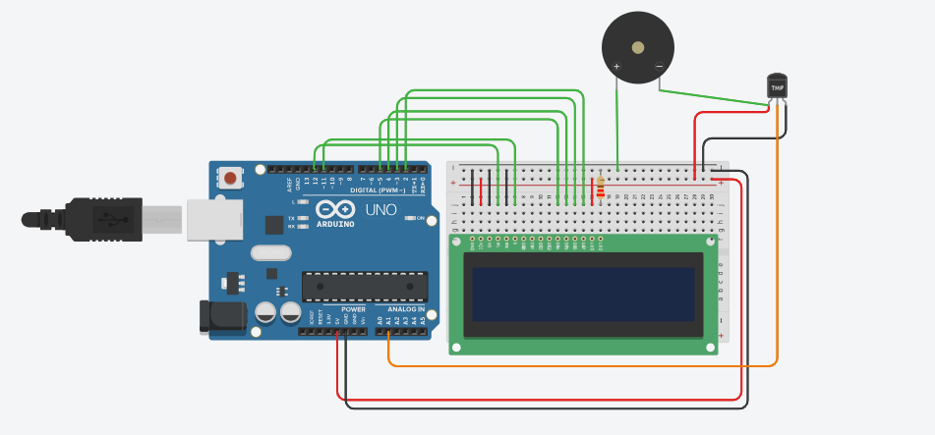

**Schematic Diagram :**

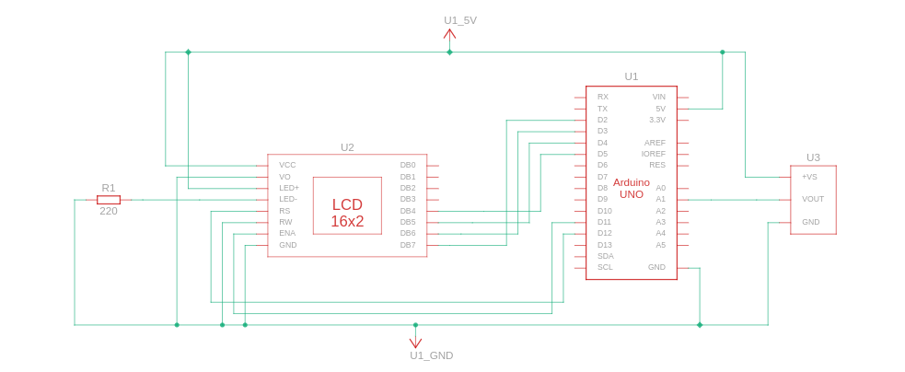

**Code :**

#include <LiquidCrystal.h>

// Define LCD pin connections

const int RS = 12, EN = 11, D4 = 5, D5 = 4, D6 = 3, D7 = 2;

LiquidCrystal lcd(RS, EN, D4, D5, D6, D7);

// Temperature sensor pin

const int TEMP_SENSOR = A1;

void setup() {

lcd.begin(16, 2); // Initialize LCD (16x2 display)

pinMode(TEMP_SENSOR, INPUT);

}

void loop() {

// Read temperature sensor value

float voltage = analogRead(TEMP_SENSOR) * (5.0 / 1023.0);

float temperature = (voltage - 0.5) * 100.0;

// Display temperature on LCD

lcd.setCursor(0, 0);

lcd.print("Temperature:");

lcd.setCursor(0, 1);

lcd.print(temperature);

lcd.print(" C");

delay(1000); // Update every second

lcd.clear();

}

**Results :**

The **LCD screen** will display real-time temperature readings.

* The temperature sensor will measure the surrounding temperature and send the data to the **Arduino**.
* The **LCD will update every 1 second**, showing the current temperature in **Celsius**.
* If the temperature changes, the display will reflect the new value dynamically.
* This cycle will **repeat indefinitely**, continuously monitoring and displaying temperature readings.

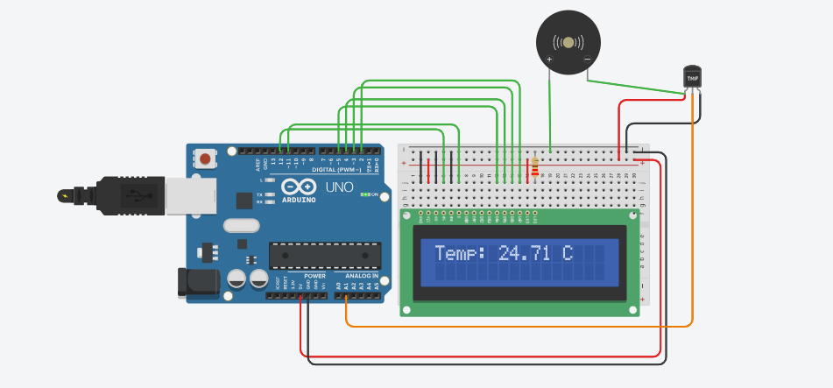

**Conclusion :**

This project successfully **interfaces an LCD and a temperature sensor** with an Arduino. It provides practical experience with **sensor integration, data display and I2C communication**. It can be extended for **real-time temperature monitoring in smart home systems**.